Student Name: Curtis Collins
Student Name: Lee-Ong Sim
Section #: 035 POD# 6 R# 1
10 Marks total.
[1 Mark] IP addressing for subnet
IP Address: 10.250.250.0 |  | Subnet mask: 255.255.255.252
Subnet | First host address | Last host address | Broadcast
10.250.250.252 | 10.250.250.253 | 10.250.250.254 | 10.250.250.255

[1 Mark] Logical Topology: workstation and router
Host1
IP Address | 10.250.250.253
IP Mask | 255.255.255.252
Gateway Address | 10.250.250.254
Router1 Interface Fa0/0
IP Address | 10.250.250.254
IP Mask | 255.255.255.252

[1 Mark] Configure Cisco Router.
Copy and paste the Cisco router configuration output
Router1#show running-config
Building configuration...

Current configuration : 726 bytes
!
version 12.2
service timestamps debug uptime
service timestamps log uptime
no service password-encryption
!
hostname Router1
!
enable secret 5 $1$e1EG$GY.6xPlH3R8boZfA1BpI3/
!
memory-size iomem 10
ip subnet-zero
!
!
!
call rsvp-sync
!
!
!
!
!
!
!
!
interface FastEthernet0/0
description Interface for Host1
ip address 10.250.250.254 255.255.255.252
duplex auto
speed auto
!
interface Serial0/0
no ip address
shutdown
!
interface Serial0/1
no ip address
shutdown
!
ip classless
ip http server
!
!
dial-peer cor custom
!
!
!
banner motd ^C
Unauthorized access will be prosecuted to the full extent of the law!!
have a nice day
^C
!
line con 0
password class
login
line aux 0
line vty 0 4
password class
login
!
end

[1 Mark] Configure hosts computers
Copy and paste the host's ipconfig output

Windows IP Configuration

Ethernet adapter VMware Network Adapter VMnet8:

Connection-specific DNS Suffix . :
IP Address. . . . . . . . . . . . : 192.168.161.1
Subnet Mask . . . . . . . . . . . : 255.255.255.0
Default Gateway . . . . . . . . . :

Ethernet adapter VMware Network Adapter VMnet1:

Connection-specific DNS Suffix . :
IP Address. . . . . . . . . . . . : 192.168.255.1
Subnet Mask . . . . . . . . . . . : 255.255.255.0
Default Gateway . . . . . . . . . :

Ethernet adapter Local Area Connection:

Connection-specific DNS Suffix . :
IP Address. . . . . . . . . . . . : 10.250.250.253
Subnet Mask . . . . . . . . . . . : 255.255.255.252
Default Gateway . . . . . . . . . : 10.250.250.254

[1 Mark] Insert Screen capture of TFTP Server receiving the configuration file

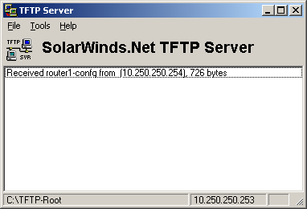

[1 Mark] Insert Screen capture of TFTP server sending the configuration file

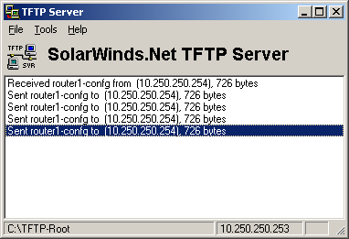

[1 Mark] Insert Screen capture of TFTP Server receiving the IOS file

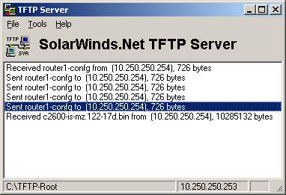

[2 Marks] Configure the loopback interface
Copy and paste the portion of the configuration file that shows the loopback interface configuration

!
interface Loopback1
description Loopback device
ip address 10.10.10.5 255.255.255.0
!

[1 Mark] Restoring the router to default configuration
To be verified by the Lab Instructor.

